Sanosil Easy Fog

DESCRIPTION

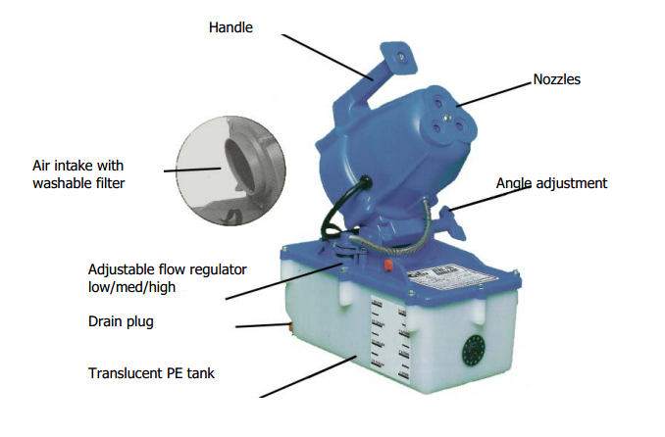
The Sanosil Easy Fog is a portable, electric cold fogging unit for the aerosol application of Sanosil S010. It is the ideal device for simple and fast surface disinfection of small and medium sized areas. The universal motor operates at a speed of approximately 20,000 r.p.m creating a powerful air stream .Sanosil S010 is sprayed in aerosol or mist sized droplets through three rugged nylon nozzles. The mist slowly settles on the surfaces to be treated and thanks to the small size of the droplets, even reaches corners and places difficult to access.

Technical Data

Dimensions
- Length: 330mm
- Width: 203mm
- Height: 356mm

Weight
- 3kg (empty)

Tank Capacity
- Approximately 4 litres

Motor
- 220V 3.5 Amps

Flow Rate
- 0- 16 litrs/hour (adjustable low/medium/high)

Projection Range
- Approximately 7 m

Particle Size
- 7- 30 µm

