**Sanosil Halo**

**DESCRIPTION**

The Sanosil Halo is an electrically operated device for the simple and effective aerosol application of Sanosil S010.disinfectant. The aerosol particles sprayed have good suspension characteristics and spread easily into the room. After a few minutes the fine droplets sediment and wet all surfaces within the treated area. The thin film of the used Sanosil disinfectant can now disinfect the surface and evaporate (speed of evaporation depending on ambient temperature) without leaving any visible deposits.

**WORKING PRINCIPLE**

The Sanosil Halo is easy to handle and works fully automatically. All that needs to be done is to select the estimated room volume and too switch on the device. Within just a few minutes the disinfectant Sanosil S010 will be dispensed in a very fine mist, effectively killing all pathogens and bacteria present in the room.

**Sanosil Halo** may be used for

▪ Surface disinfection

▪ Aerosol disinfection

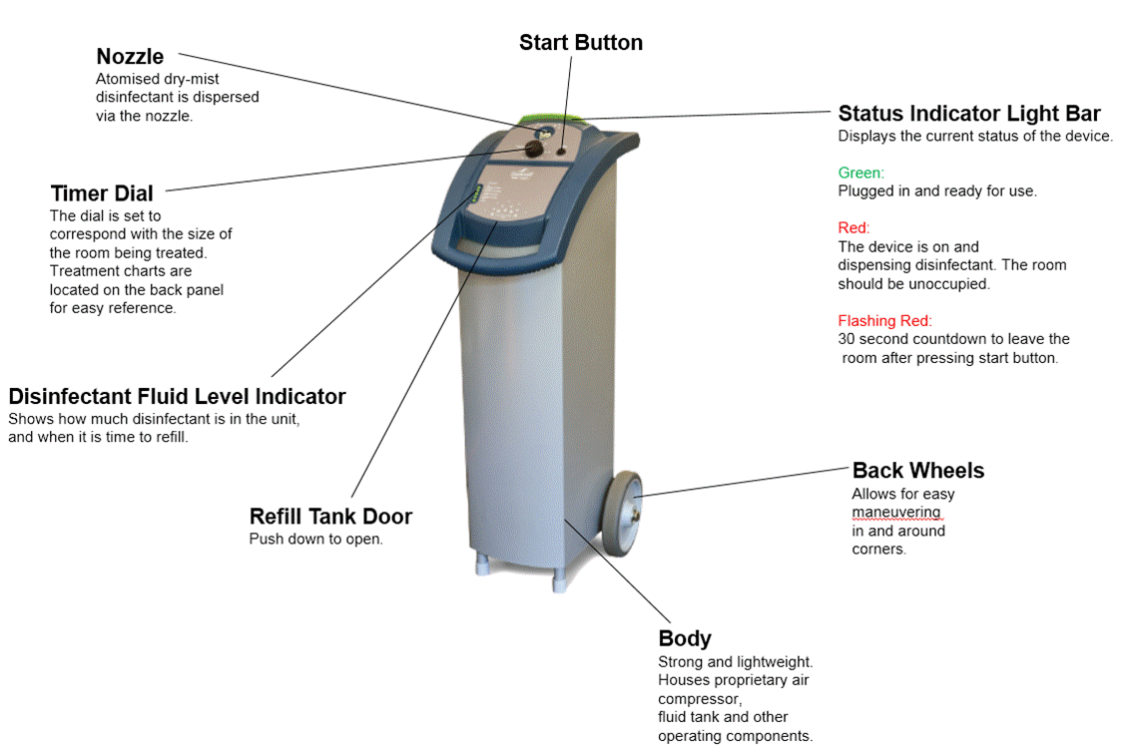

**ADAVANTAGES**

* Safe and simple handling
* Reliable
* No labour involved
* A clean solution

**ROOM TREATMENT PROTOCOL**

Treatment times are calculated based on room volume. For efficacy and safety purposes, the room should remain unoccupied for 90 minutes after treatment.

|  |  |  |  |  |  |
| --- | --- | --- | --- | --- | --- |
| Room Size | | Ceiling | Room Volume | Run Time | Disinfectant Use |
| Small | 4.6m x 7m (15ft x 20ft) | 2.45m  (8ft) | 80m3 (2400ft3) | 18 Min. | 500ml (18 oz) |
| 3.00m  (10ft) | 95m3 (3000ft3) | 22 Min | 600ml (22oz) |
| Medium | 7m x 9m (15ft x 20ft) | 2.45m (8ft) | 154m3 (4800ft3) | 36 Min | 1000ml (36 oz) |
| 3.00m (10ft) | 189m3 (6000ft3) | 45 Min | 1250ml (45 oz) |
| Large | 9m x 9m (15ft x 20ft) | 2.45m (8ft) | 200m3 (7200ft3) | 54 Min | 1500ml (54oz) |

**TECHNICAL CHARACTERISTICS**

**Applied Technology**

* Ionized, fine mist
* Solid state electronic control
* Proprietary nozzle and compressed air

system

**Particle Size**

* 5-10 microns

**Dimensions**

* Height 116cm (40.0”)
* Width 33.6cm (12.25”)
* Depth 47cm (18.5”)
* Weight 20kg (43lbs)

**Tank Size**

* **7.5 litres (2 gallons)**

**Safety Features**

* Delayed start
* Door sensor
* Fluid level indicator
* Internal splash guard
* Status indicator light bar